**Green ICT Application User Manual**

ADNA Team:

Anh Le, Duc Pham, Nguyen Tran, An Pham



USE CASES

* As an admin you are able to:
* View and set up new general locations
* View all appointments
* View all users as well as modifying and deleting them
* Modify your own profile
* As a service person you are able to:
* View and set up new service product as setting new private locations.
* View and set up new free time slots
* View all your appointments
* Modify your own profile
* As a client you are able to:
* Book new appointment and choose free time slot
* View all your appointments and cancel any of them
* Modify your profile
* Anyone can sign up for a new account by register page.

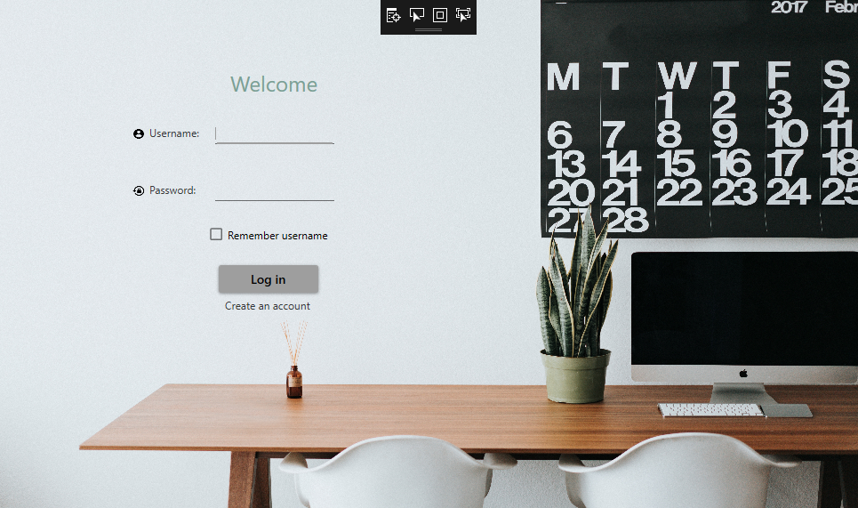

# Home Page

This is the application’s homepage.

You can log in if you already have an account

Or sign up for a new account.

___________________________________________________________________________________

___________________________________________________________________________________

_______________________________________________________________________________________________

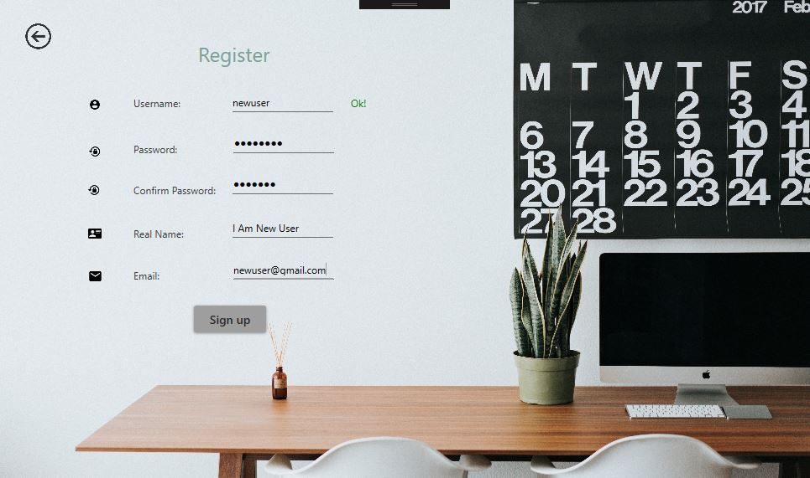

# Register Page

To register, first, fill your user name in “Username” field.

Insert twice your password in “Password” and “Confirm Password”.

Add your real name and personal email within the fields.

Press “Sign up” to become a member of the application.

___________________________________________________________________________________

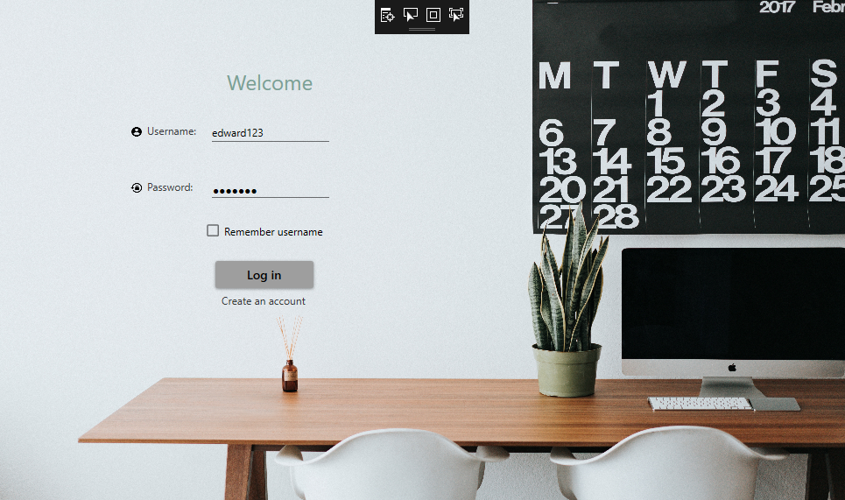

# Log In

Type in your username at “Username” field.

Type in your password at “Password” field.

Press “Log in”

___________________________________________________________________________________

___________________________________________________________________________________

_______________________________________________________________________________________________

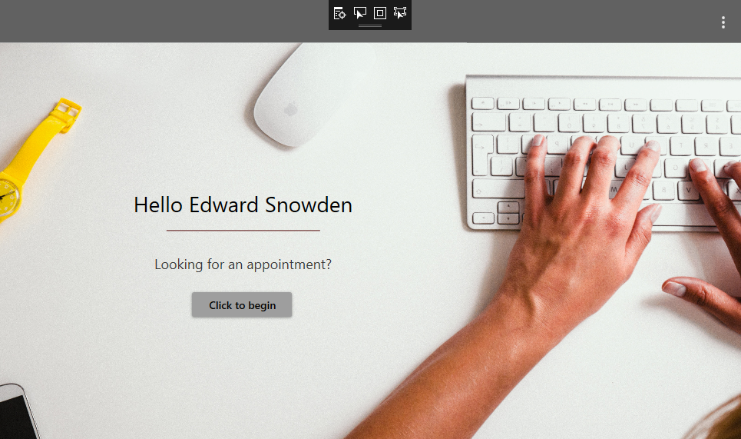

# Welcome Page

If your account type is “Clients”, after pressing “Log in”, the Welcome page will pop-up as a greeting.

You can start interacting with the application by pressing “Click to begin”

___________________________________________________________________________________

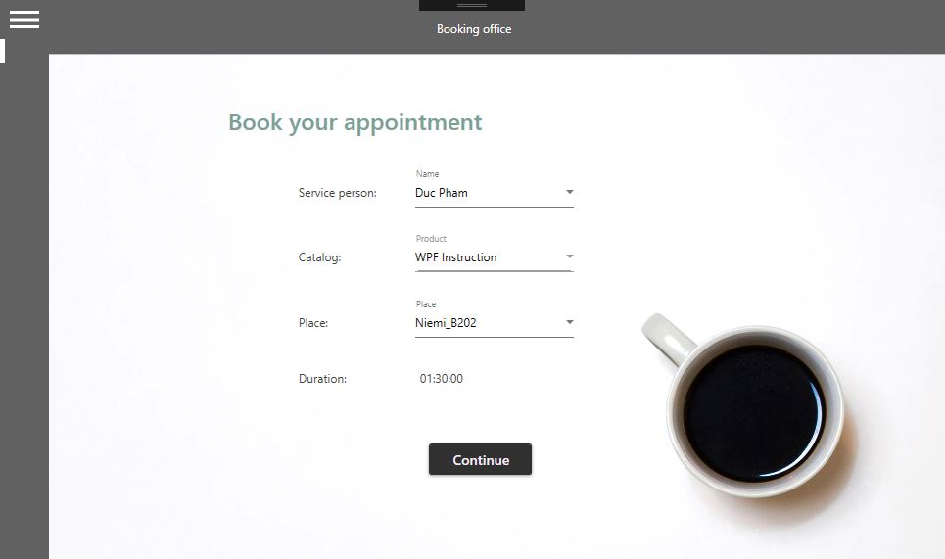

# Book Appointment

First, choose a service person.

Then choose a subject or class or course, etc.…

Afterward, choose a location and the duration of your appointment will be automatically displayed.

___________________________________________________________________________________

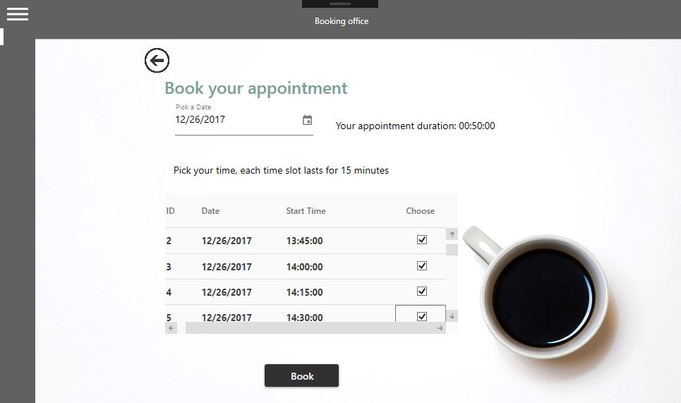

# Book time for your appointment

After choosing your appointment, you will book time for it.

First pick a date by opening the calendar.

Next, you have to pick the total duration of time that match your appointment duration, which is showed next to the date you picked.

After pressing “Book”, a success message will pop up to inform you.

_______________________________________________________________________________________________

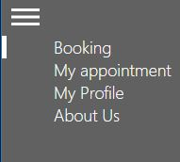

# Client’s Menu

This the menu, which you can enter by pressing the button on the top left corner.

“Booking” helps you book appointments.

“My appointment” helps you check how many appointments you are having at the moment.

Press “My profile” shows you information of your account.

“About us” gives you information of the developing team.

_______________________________________________________________________________________________

# 

# Make A Choice

This is the front page of “Service Person” accounts.

You can select one of these.

Press “Service Product” if you want to know what are the services you have.

And if you want to choose to see service time, press “Service Time”

# __________________________________________________

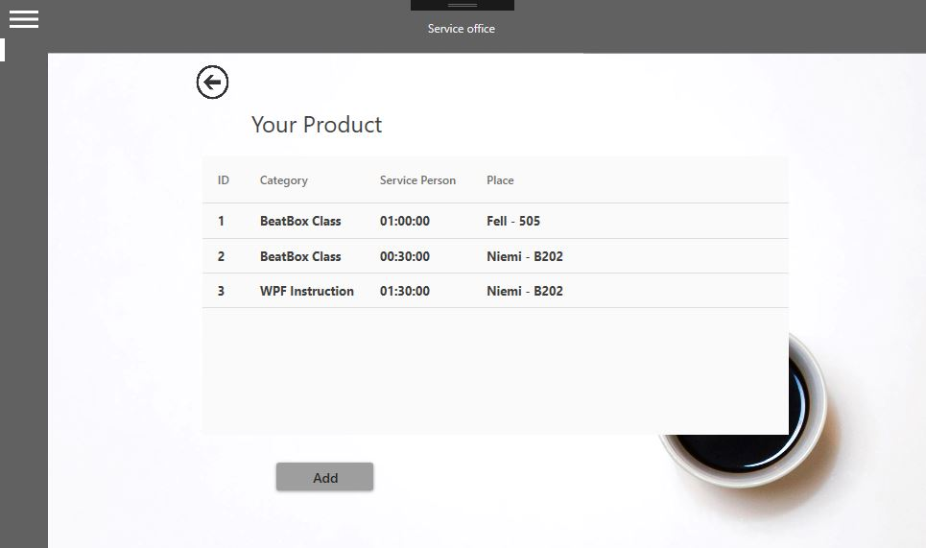

# View Services

If you press “Service Product”, you will be navigated to this page.

This is where you can see what services you have at the moment.

Press “Add” to add a service with time and location.

___________________________________________________________________________________

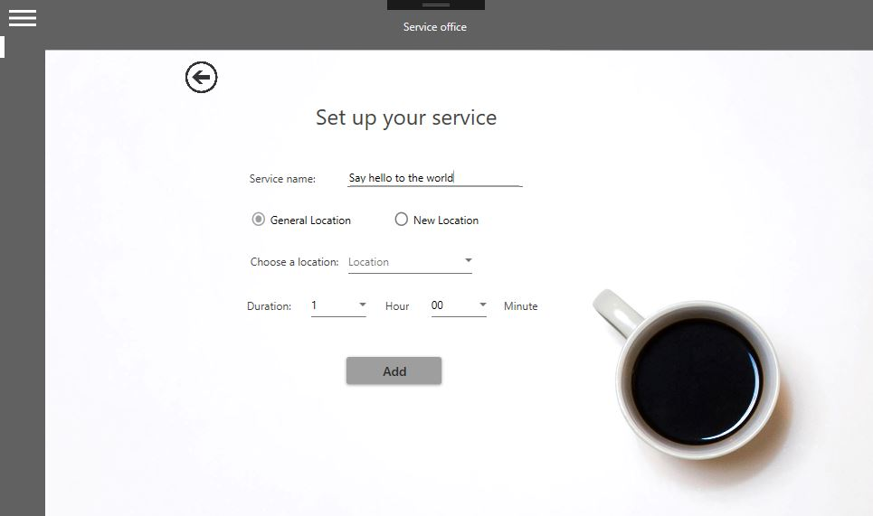

# Add Service

Here you can set up your service.

First give it a name by filling “Service name” field.

Choose one from “General Location” and “New Location”.

___________________________________________________________________________________

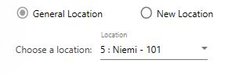

If you choose “General Location”, a drop-down will pop up, letting you choose some existed locations which is general or belongs to specified service person.

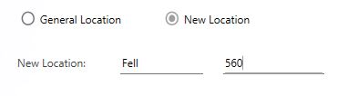

If your choice is “New Location”, two blank spaces will show up.

This is where you add new locations.

_______________________________________________________________________________________________

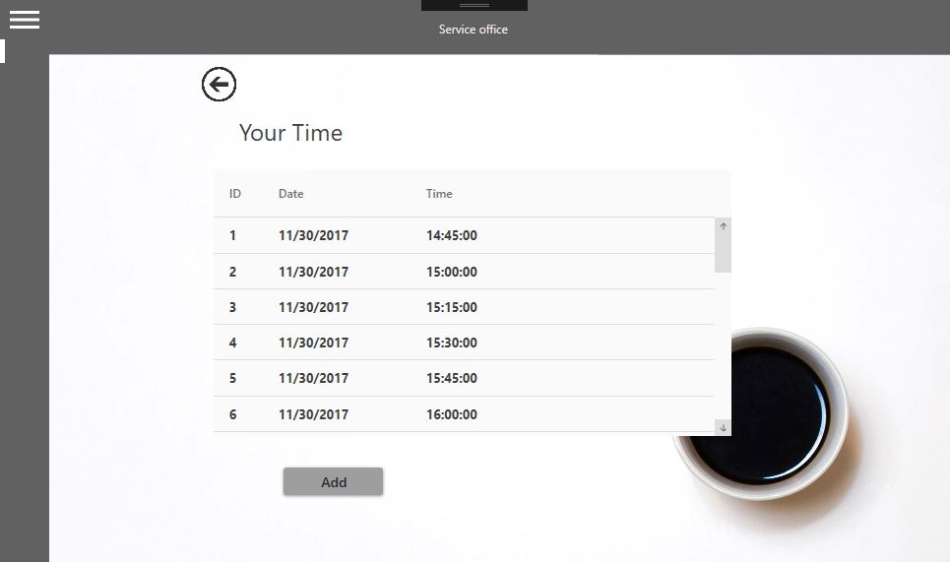

# View Time

This is your destination if you pressed “Service Time” instead.

Here you can find your booked times.

Press “Add” to add more time to your appointments.

___________________________________________________________________________________

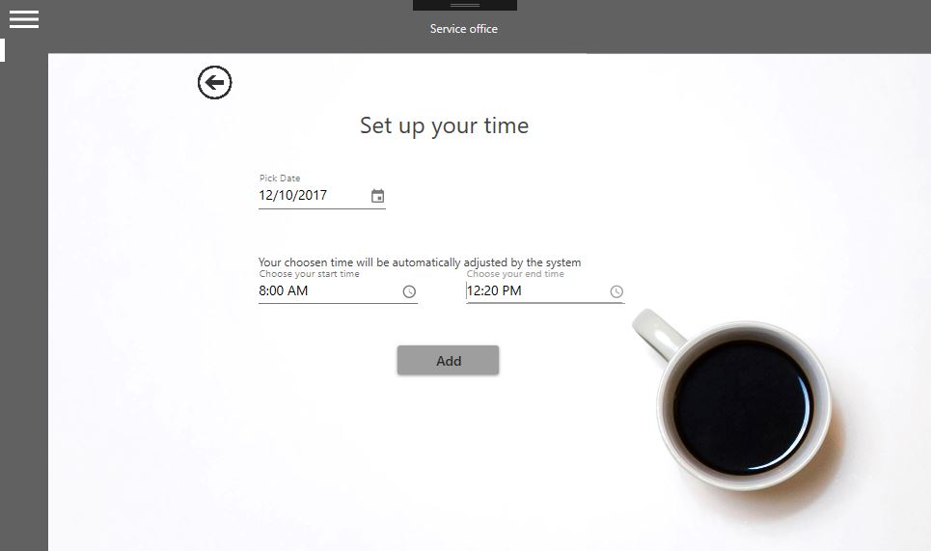

# Add Time

To add time, first, pick a date from the “Pick Date” field.

You can click the small calendar to directly choose it from the calendar.

Then choose your start and end time and the system will automatically adjust them.

The small clocks at the end of both fields will allow you to choose time from live clocks for more precision.

_______________________________________________________________________________________________

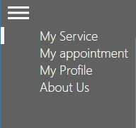

# Service Person’s Menu

“My Service” category helps you create and add more services.

“My Appointment” shows you your appointments.

“My Profile” is where you find your account’s information

“About Us” gives you information of the development team.

___________________________________________________________________________________

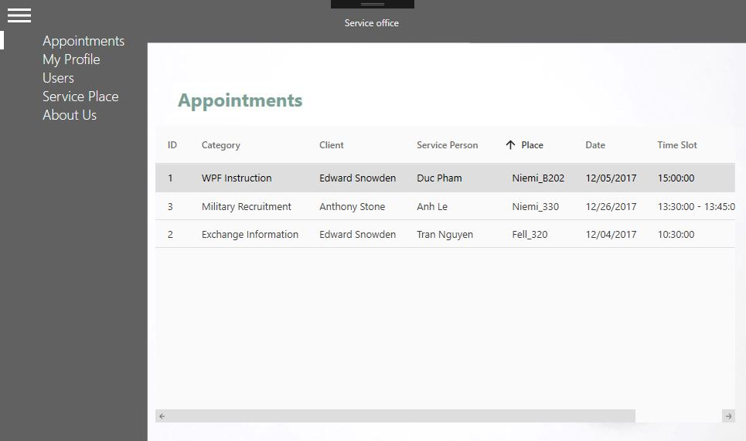

# Appointments

Here is the front page of the admin account.

This is where all appointments made by users are displayed.

You can check their time, location, clients who booked it and its category.

___________________________________________________________________________________

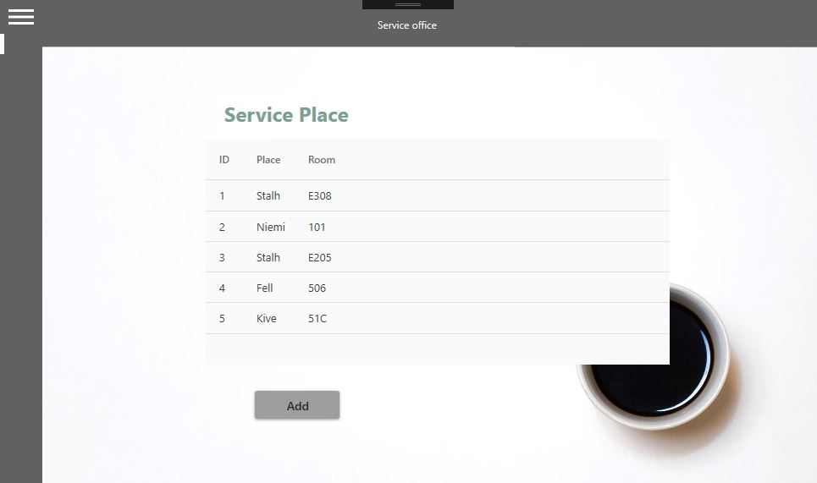

# View Service Places

You can see how many service places have been added by Service person.

You can add more general service places at your will.

Simply press “Add” and get to the next step.

___________________________________________________________________________________

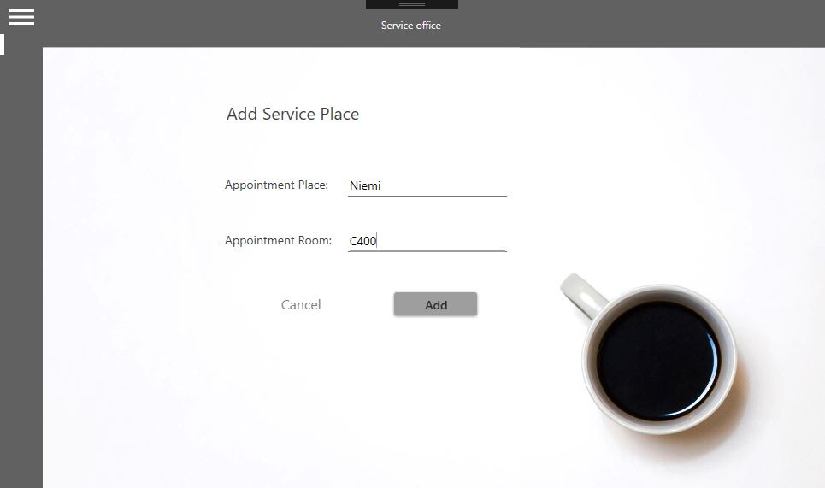

# Add Location

As an admin, you can add more general service places.

First, fill “Appointment Place” and “Appointment Room” to choose location.

Press “Add” to confirm.

___________________________________________________________________________________

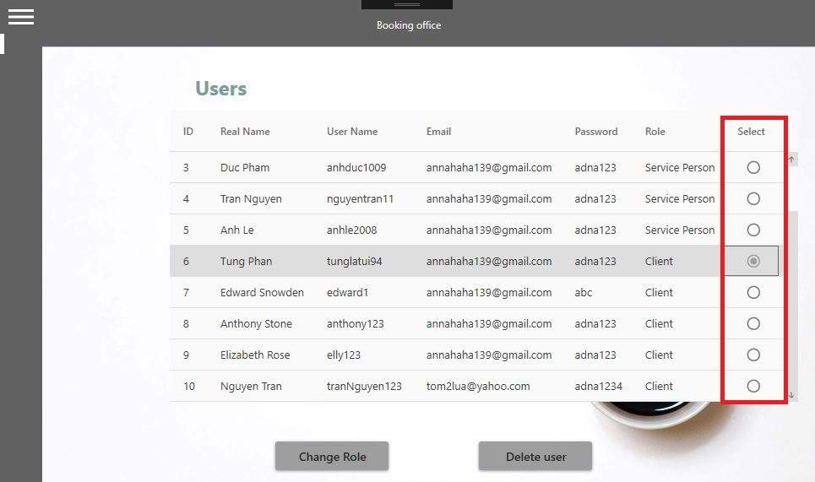

# View and Edit Users

You can edit user’s information and roles.

Tick a radio box after any user you want to edit.

After that you can press “Change Role” to upgrade or downgrade their roles.

Or you can press “Delete user” to delete him or her from the database

___________________________________________________________________________________

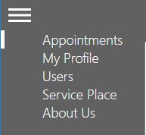

# Client’s menu.

“Appointments” shows you all appointments made by clients.

“My Profile” shows you your account’s information.

“Users” is section you can find and edit users’ information or their roles.

“Service Place” is the section where you add more general service places.

“About Us” is information of development team.

_______________________________________________________________________________________________

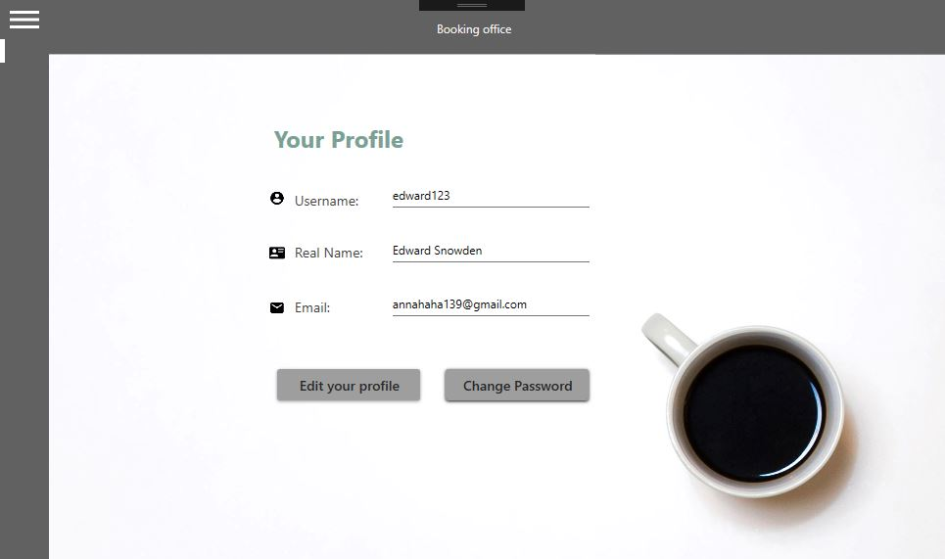

# Profile Page

Any type of account has the same profile page.

This is where you find information of your account.

You can edit your username, real name and email by clicking “Edit your profile”.

If you want to change your password, simply just click “Change Password”.

_______________________________________________________________________________________________

___________________________________________________________________________________

_______________________________________________________________________________________________